Project Design Phase-II Data Flow

Diagram & User Stories

|  |  |
| --- | --- |
| Date | 1 July 2025 |
| Team ID | LTVIP2025TMID44259 |
| Project Name | Pattern Sense: Classifying Fabric Patterns using Deep Learning |
| Maximum Marks | 4 Marks |

Data Flow Diagrams:

A Data Flow Diagram (DFD) is a tradi onal visual representa on of the informa on flows within a system. A neat and clear DFD can depict the right amount of the system requirement graphically. It shows how data enters and leaves the system, what changes the informa on, and where data is stored.

Flow Diagram:

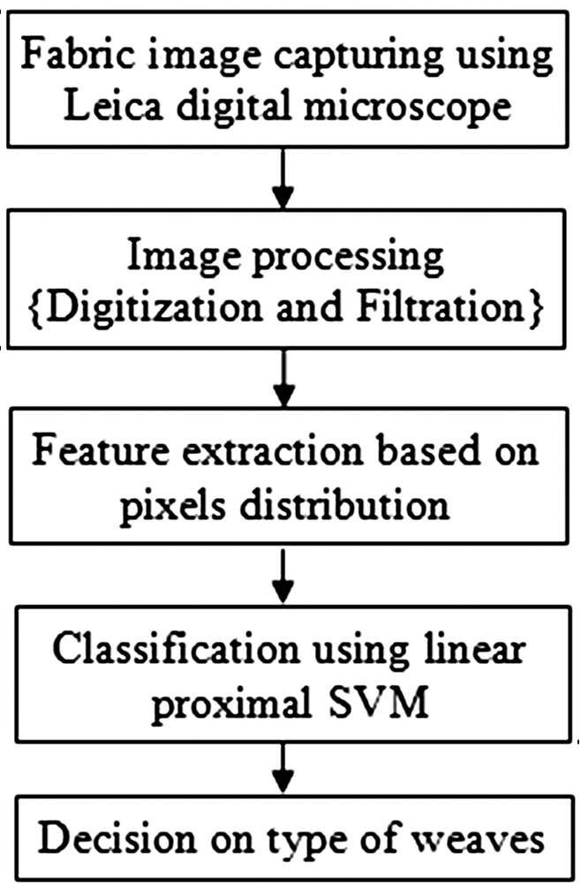

User Stories

Use the below template to list all the user stories for the product.

|  |  |  |  |  |  |  |
| --- | --- | --- | --- | --- | --- | --- |
| User Type | Func onal  Requirement  (Epic) | User  Story  Number | User Story /  Task | Acceptance  criteria | Priority | Release |
| Admin /  Developer | Dataset & Preprocessin g | USN-1 | As a developer, I want to upload and preprocess fabric images so the model receives clean, normalized data. | Images are resized, augmented, and stored in the correct format. | High | Sprint-1 |
|  | Define  Pa ern  Categories | USN-2 | As a researcher, I want to define and standardize fabric pa ern categories for consistent labelling.. | A finalized list of labels is available and used across dataset and model training. | High | Sprint-1 |
| System | Image  Classifica on  Model | USN-3 | As a system, I need to classify fabric pa erns  using a  CNN model and return the top predic on  with confidence. | Model provides output within acceptable accuracy threshold (e.g.,  >85%) and includes confidence score. | High | Sprint-2 |
|  | Model  Training &  Evalua on | USN-4 | As a developer, I want to train | Model is trained, tested, and | Low | Sprint-3 |

|  |  |  |  |  |  |  |
| --- | --- | --- | --- | --- | --- | --- |
| User Type | Func onal  Requirement  (Epic) | User  Story  Number | User Story /  Task | Acceptance  criteria | Priority | Release |
|  |  |  | the model using the  prepared dataset and evaluate it using valida on/te st splits. | evalua on  metrics (accuracy, F1score) are documented |  |  |